

**NAME:** KASHIF MAJID DAR

**DIVISION:** CS B1

**PRN:** 19070122084

***ASSIGNMENT 5***

***TITLE:*** *CONTROL STRUCTURE*

# *AIM:* Write a program to find 1) Fibonacci series for given term 2) Factorial of given number 3) Reverse of an integer

***THEORY:***

In this assignment, we use loop structure to find out whether a number is odd/even, prime/composite or if a year is leap year or not.

We check the conditions using if…else statements in C language.

**if…else:**

The if statement evaluates the test expression inside the parenthesis ().

* If the test expression is evaluated to true, statements inside the body of if are executed.
* If the test expression is evaluated to false, statements inside the body of if are not executed.

**syntax**:

if (test expression)

{

// statements to be executed if the test expression is true

}

**WHILE loop:**

* The while loop evaluates the test expression inside the parenthesis ().
* If the test expression is true, statements inside the body of while loop are executed. Then, the test expression is evaluated again.
* The process goes on until the test expression is evaluated to false.
* If the test expression is false, the loop terminates (ends).

**syntax**:

white (testExpression)

{

// statements inside the body of loop

}

**SWITCH CASE:**

**Syntax:**

**switch (expression)**

**​ {**

**case constant1:**

**// statements**

**break;**

**case constant2:**

**// statements**

**break;**

**.**

**.**

**.**

**default:**

**// default statements**

**}**

* The expression is evaluated once and compared with the values of each case label.
* If there is a match, the corresponding statements after the matching label are executed. For example, if the value of the expression is equal to constant2, statements after case constant2: are executed until break is encountered.
* If there is no match, the default statements are executed.
* If we do not use break, all statements after the matching label are executed.
* By the way, the default clause inside the switch statement is optional.

***PROGRAM 1:***

***Algorithm:***

Step 1: Start

Step 2: Input number of terms to be checked.

Step 3: declare standing value of series ie 0&1, and print them.

Step 4: Using while loop for given number of terms add previous two terms.

Step 5: Now continue loop for n terms and print the value of a and b.

Step 6: End

***FLOWCHART:***

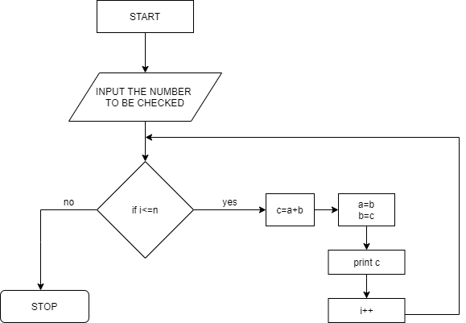

***SOURCE CODE:***

#include <stdio.h>

#include <stdlib.h>

/* run this program using the console pauser or add your own getch, system("pause") or input loop */

main() {

int a,i,f1=0,f2=1,f3;

printf("ENTER THE LIMIT UPTO WHICH YOU WANT FIBONACCI NUMERS:");

scanf("%d",&a);

printf("THE FIBONACCI SERIES IS: %d %d ",f1,f2);

for(i= 0; i < a; i++)

{

f3 = f1 + f2;

printf("%d ",f3);

f1 = f2;

f2 = f3;

}

}

***OUTPUT:***

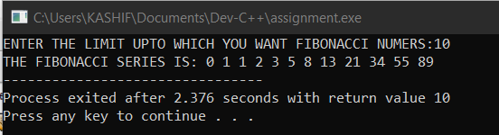

***PROGRAM 2:***

***Algorithm:***

Step 1: Start

Step 2: Input number of terms to be checked.

Step 3: Using for loop starting from 1 to no. entered by user, multiply the factorial variable by counter variable of for loop.

Step 4: Print factorial of that number.

Step 5: End

***Flowchart:***

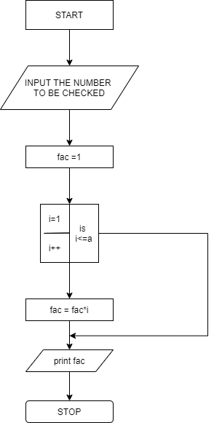

***Source code:***

#include <stdio.h>

main()

{

int c, n, f = 1;

printf("Enter a number :\n");

scanf("%d", &n);

for (c = 1; c <= n; c++)

f = f * c;

printf("Factorial of %d = %d\n", n, f);

}

***OUTPUT:***

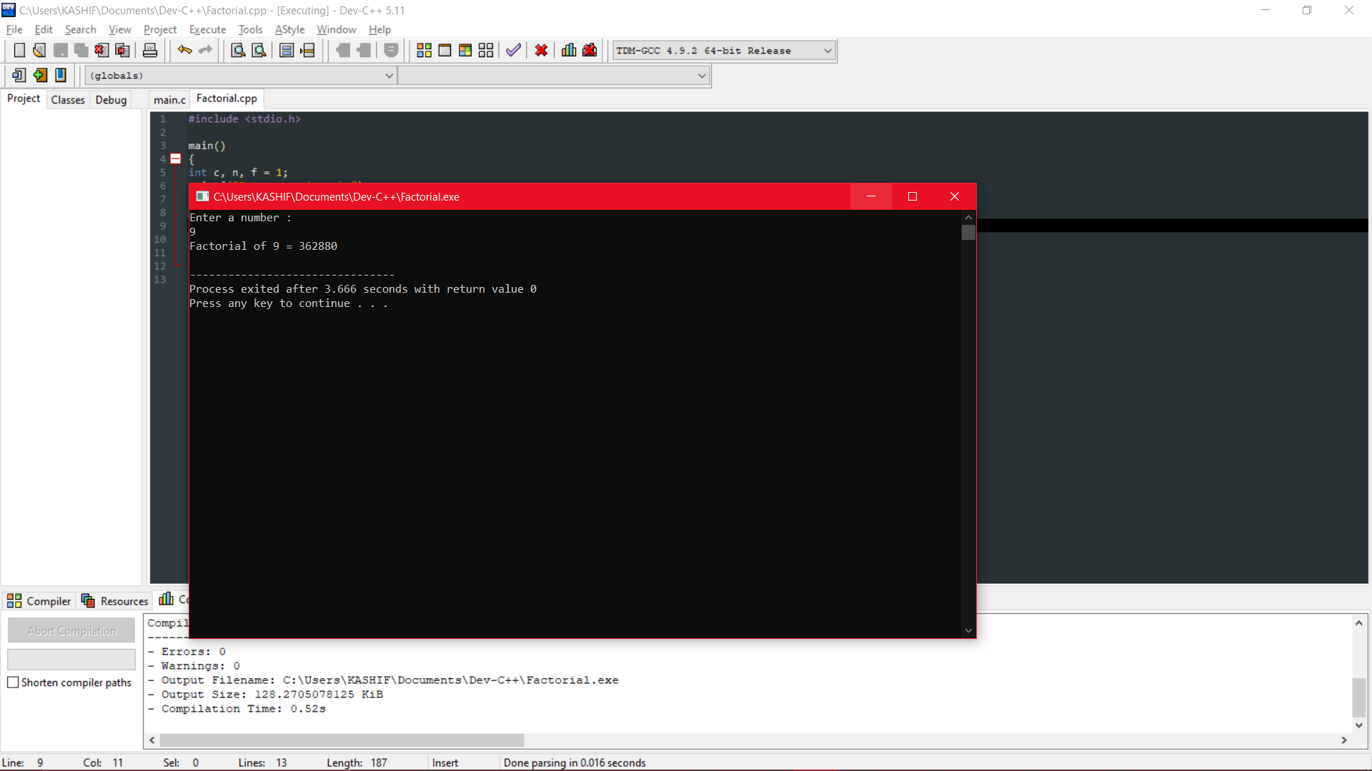

***PROGRAM 3:***

***Algorithm:***

Step 1: Start

Step 2: Input number.

Step 3: Check if, number>0, we use while loop, multiply reverse variable with 10.

Step 4: Add remainders of original no. after dividing it by 10.

Step 5: Divide original number by 10 and continue executing the loop for no. greater than 0.

Step 6: Print reversed number

Step 7: Stop

***Flowchart:***

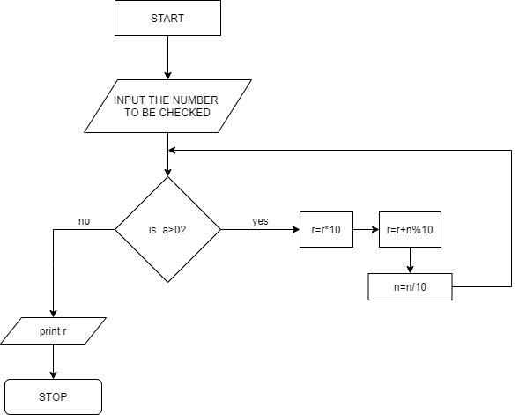

***SOURCE CODE:***

#include <stdio.h>

#include <stdlib.h>

main() {

int n,r;

printf("Enter the number to be checked: ");

scanf("%d", &n);

while (n!=0)

{

r=r*10;

r=r+n%10;

n=n/10;

}

printf("Reverse is %d", r);

}

***OUTPUT:***

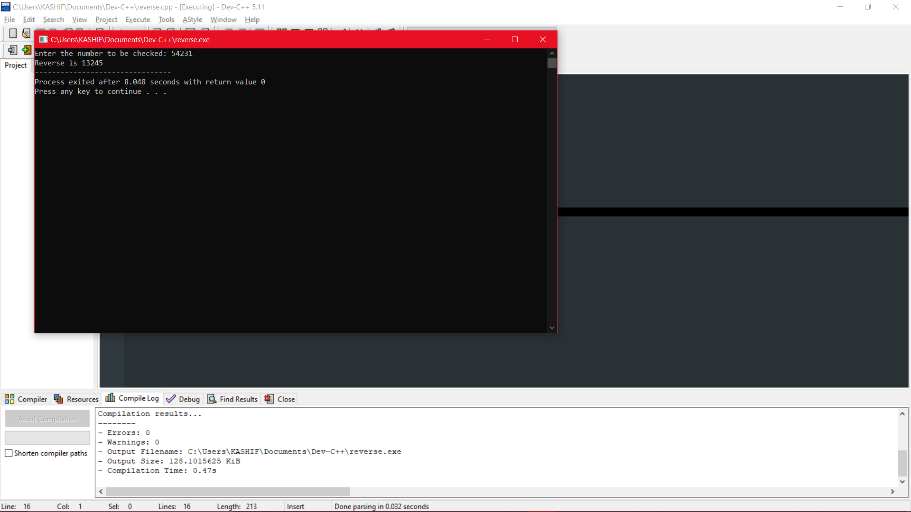

***CONCLUSION:***

In this experiment, we understand the use of while loop and find out the Fibonacci series, reverse of a number and factorial of a number.